Hello Neighbor,

I have noticed several cats on and around your property. If you are feeding them, thank you!  I am leaving you this letter because I would like to help by getting the cats sterilized so they don’t keep reproducing, and vaccinated so they stay healthy. I will return all of the cats unless they are young kittens or friendly and you’d like assistance in re-homing them.  This practice is called Trap-Neuter-Return (TNR). | 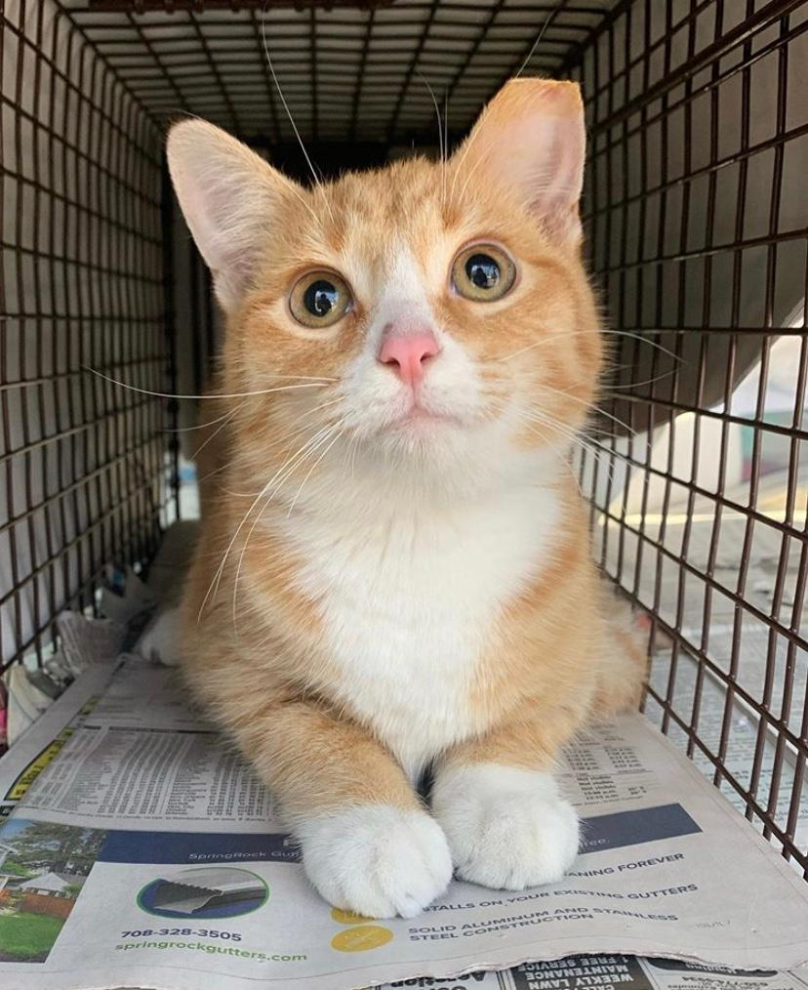
Unless we spay them, female cats can produce 3-4 litters of kittens per year, with an average litter size of 5 kittens. A cat can get pregnant as early as 4 months old and can become pregnant again while still nursing a prior litter. About 60% of kittens that are born outside die before reaching 6 months of age. Please help break the chain of breeding and untimely death.

The cats will also be vaccinated against rabies and several common cat viruses, such as distemper and calici, which will keep them much healthier.

In Cook County, we are very lucky to have the Managed Care of Feral Cats Ordinance, which allows people to feed and care for cats legally. I can help you to sign up for the program. Your name and contact info will not be shared with the City or County.

The TNR process involves catching the cats in high-quality, safe humane traps which do not harm them in any way. Cats are sterilized, vaccinated, treated for fleas and ear mites, left ear-tipped (See above photo), micro-chipped, and returned to the same location.

Please give me a call, so we can work together to help the cats.

Sincerely,

